**Select list validation in asp.net core**

**required validation on a select list in ASP.NET Core**. Let's understand this with an example.  
  
  
Consider the following *Create Employee Form*  
  
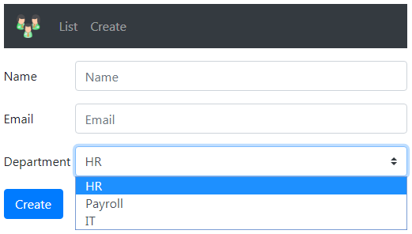  
  
  
We want to make the *"Department"* field required. Among the options, we want *Please Select*as the first option. *Please Select*is not a valid selection, it is just an option to prompt the user to select a valid department.  
  
The *Department*select list is bound to the following Dept enum.

public enum Dept

{

    None,

    HR,

    Payroll,

    IT

}

**Department Select List HTML**  
  
Notice, we are using *asp-items*tag helper to bind *Department*select list to Dept enum

<div>

    <**label** **asp-for**="Department"></**label**>

    <div>

        <**select** **asp-for**="Department" **asp-items**="Html.GetEnumSelectList<Dept>()">

        </**select**>

    </div>

</div>

**Select List First Option**  
  
We want the first option in the Select List to be *Please Select*. The easiest way to achieve this is by including an <option> element in the select list HTML as shown below.

<div>

    <**label** **asp-for**="Department"></**label**>

    <div>

        <**select** **asp-for**="Department" **asp-items**="Html.GetEnumSelectList<Dept>()">

            <**option** **value**="">Please Select</**option**>

        </**select**>

        <**span** **asp-validation-for**="Department" class="text-danger"></**span**>

    </div>

</div>

*value*attribute of the *Please Select*option element is set to an empty string. We are also using *asp-validation-for* tag helper to display the validation error. To apply red font-clolor to the validation error, we are using *text-danger*Bootstrap class.  
  
**Making Select List Required**  
  
The Select List is bound to *Department* property of the Employee model class. To make the *Department*Select List required, apply [Required] attribute on the *Department*property of the Employee class.

public class Employee

{

    public int Id { get; set; }

    public string Name { get; set; }

    public string Email { get; set; }

    [Required]

    public Dept Department { get; set; }

}

At this point if we run the project and submit the form without selecting a valid department from the select list we get the error - The value '' is invalid.  
  
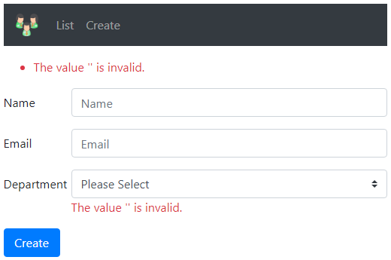  
  
The error that we are getting here is not the required validation error. To prove this, remove the [Required] attribute from the *Department*property of the Employee class and you will still get the same error.  
  
Let's first understand why we are getting this error - The value '' is invalid.

* The datatype of the *Department*property is Dept enum.
* By default an enum underlying data type is int.
* An empty string is set as the value for *Please Select* option of the select list in the HTML.
* So when this option *Please Select* is selected from the select list, the value empty string is used as the value for *Department*property whose underlying data type is int.
* Obviously an empty string is not a valid value for int.
* This is the reason we get - The value '' is invalid.
* Value types (such as int, float, decimal, DateTime) are inherently required and don't need the Required attribute.

**Select List Required Validation**  
  
However, if you make the *Department*property, a nullable property by including a question mark then the [Required] attribute is needed to make the field a required field.

public class Employee

{

    public int Id { get; set; }

    public string Name { get; set; }

    public string Email { get; set; }

    [Required]

    public Dept? Department { get; set; }

}

If we now submit the form with *Please Select*option selected we get Required validation error as expected.  
  
